Name : Bola Warsy ID: 21-101147
Computer Security Project Report
1. What Have I Done in the Project?
This project comprehensively explored cryptographic algorithms by applying them to real-world multimedia files. The project was divided into three core tasks:
- Image Encryption (AES-128): I encrypted a structured .bmp image using the Advanced Encryption Standard (AES) with a 128-bit key across different modes of operation: ECB, CBC, CFB, and OFB. The goal was to secure the image data while maintaining a valid file format so the result could be observed visually.
- Digital Signature (RSA & SHA-1): I generated a 2048-bit RSA key pair, created a SHA-1 hash of the CBC-encrypted image, and signed that hash using the private key to guarantee data integrity and non-repudiation.
- Randomness Evaluation (NIST STS): I compiled and ran the official NIST Statistical Test Suite (SP 800-22) on an Ubuntu Virtual Machine to mathematically evaluate the randomness of the plaintext image versus my encrypted ciphertexts through different randomness tests.
2. Steps Followed
I created a Python script to perform the first two tasks, and in the same directory where the script existed, I attached an image and renamed it to “portal_image.bmp.”
Task 1: AES Encryption
- Read the target .bmp image and deliberately separate the 54-byte BMP header from the raw pixel body.
- Generated a secure 128-bit random key via OS entropy.
- Padded the pixel body to fit AES 16-byte block requirements.
- Encrypted the body using ECB, CBC, CFB, and OFB modes (utilizing random IVs for the latter three).
- Reattached the unencrypted header to the ciphertexts and saved them, creating my viewable encrypted .bmp images.
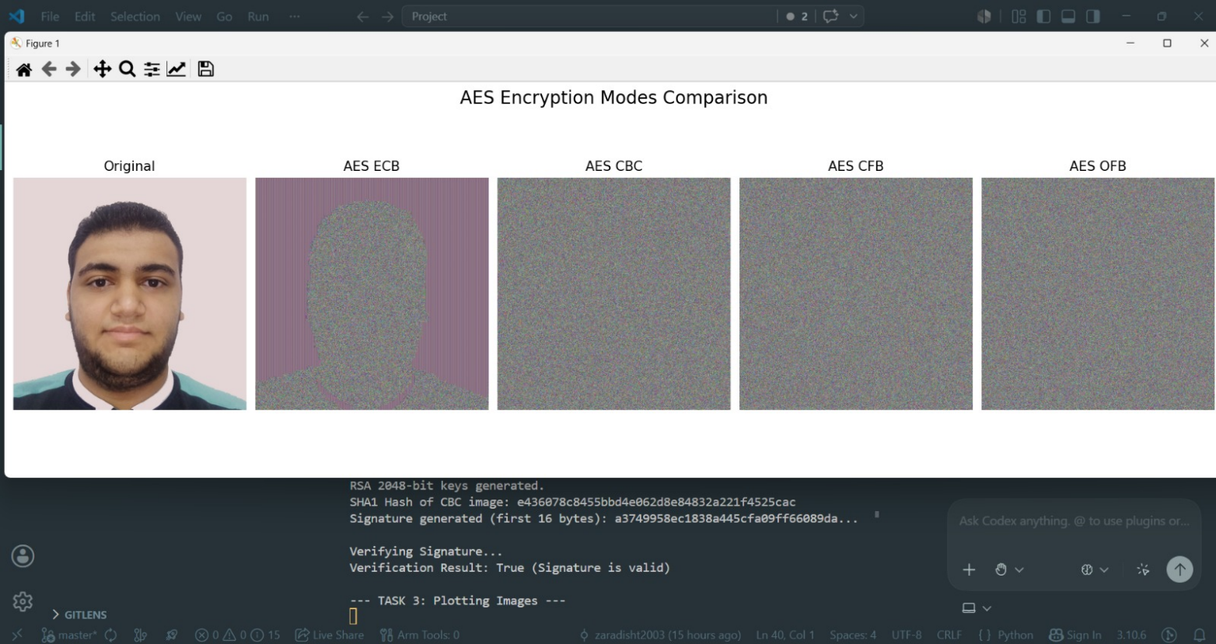
Task 2: RSA Signature
- Generated a 2048-bit RSA Public/Private key pair using pycryptodome.
- Hashed the CBC-encrypted image using the SHA-1 algorithm.
- Signed the resulting hash with the RSA private key using PKCS#1 v1.5 padding.
- Successfully verified the signature using the corresponding RSA public key.
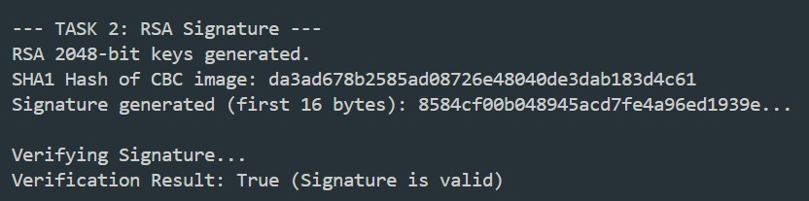
Task 3: NIST Evaluation
- I included the NIST evaluation test suite from this GitHub repo, which is similar to the original one, but it has better guidance for the user to install and start the suite.
- I published the script, the photos, and the test suite on this GitHub repo.
- I used my EUI email to set up a student account on a platform called Lightning AI, which offers a free tier computation VM for students.
- Wrote a comprehensive Bash automation script (run_nist_tests.sh) to automatically detect file bit lengths, pipe the inputs into the interactive ./assess tool, and gather the output into a single master report inside the sts directory, which includes the test suite.
- I initialized the test suite through the script and the make file with the repo , then I ran the test suite on the binary representation of the original image and the encrypted images.
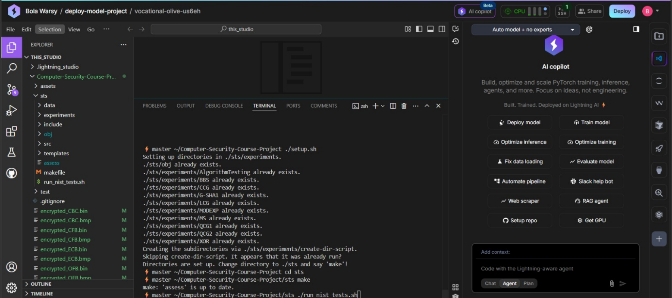
3. Results Obtained
The NIST STS results yielded a quantifiable "Pass Percentage" based on the proportion of passing tests:
- Original Image:
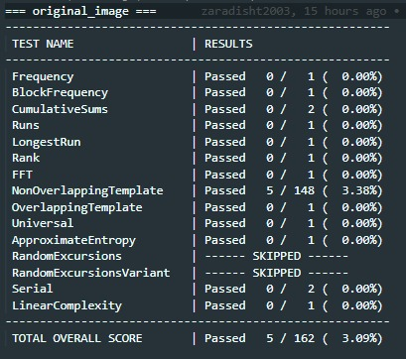
- ECB-Encrypted:
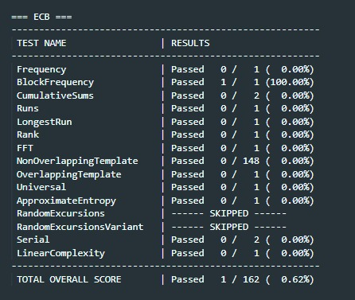
- CBC-Encrypted:
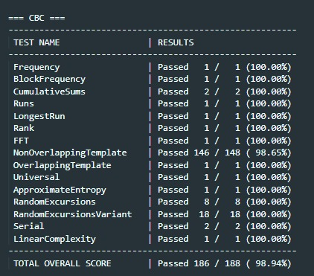
- CFB-Encrypted:
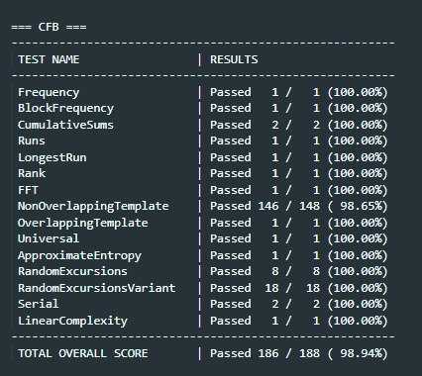
- OFB-Encrypted:
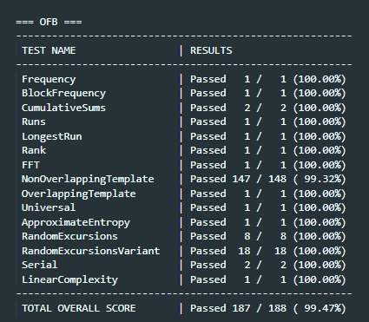
Summary:
- Original Image (Baseline): ~3.09% Pass Rate.
- AES-ECB: ~0.62% Pass Rate.
- AES-CBC: ~98.94% Pass Rate.
- AES-CFB: ~98.94% Pass Rate.
- AES-OFB: ~99.47% Pass Rate.
From the above tests, we find that ECB clearly failed the randomness test, and CBC, CFB, and OFB all passed most of the randomness tests (approximately 99%), so from that, we find that ECB is the worst in terms of randomness, and the other algorithms are nearly of the same strength in terms of randomness either visually or from the test suite.
4. Interesting Observation
- ECB performs really well and achieves the same randomness as other algorithms if the image has many details, because AES has high deviation, so if we have image fields that differ only in a very small part, they will look entirely different in the encrypted version. ECB was preserving patterns in the previous example because it contained many image fields that were exactly the same, so they were given the same hash, but in that case, very few image fields are the same.
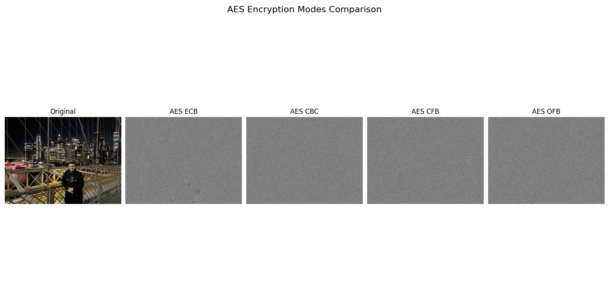
5. Conclusion:
5. Conclusion
This project successfully demonstrated how modern cryptographic techniques can be applied to multimedia data to achieve confidentiality, integrity, and statistical security. By implementing AES-128 image encryption across multiple modes, it was possible to directly compare the security behavior of ECB, CBC, CFB, and OFB both visually and mathematically. The results showed that while ECB preserved structural patterns and failed randomness evaluation, CBC, CFB, and OFB produced significantly stronger security properties and achieved very high pass rates in the National Institute of Standards and Technology Statistical Test Suite. In addition, the integration of RSA digital signatures confirmed that encrypted data can also be protected against tampering while preserving authenticity. Overall, this project highlights that secure system design requires not only strong cryptographic algorithms, but also the correct choice of mode of operation and validation through practical statistical analysis.

